**! → The figure of + {số liệu cụ thể}**

**! → Phải có so sánh các số liệu và có số liệu cụ thể qua từng năm**

**! → The proportion of / The figure for + {Uncountable and Countable Noun}**

**! → The amount of + {Uncountable Noun}**

**! → The number of + {Countable Noun}**

The figure for [U or C] Mexico reached just over 25%.

The proportion of people using the internet in the USA was about 20% [U or C].

The percentage of internet users was highest in Canada. Almost 100% of Canadians used the internet, compared to about 80% of Americans and only 40% of Mexicans.

The figures for Canada and Mexico were lower, at about 10% and 5% respectively.

In 2005, Internet usage in both the USA and Canada rose to around 70% of the population, while the figure for Mexico reached just over 25%

Canada experienced the fastest growth in the internet usage

A much larger percentage of Canadians and Americans had accessed to the Internet **IN COMPARISON WITH** Mexicans

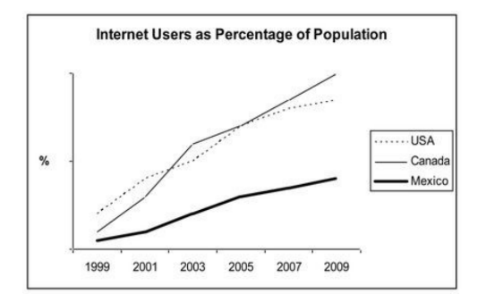

**The line graph compares (illustrates, shows) the percentage/proportion of people in three countries who used the Internet between 1999 and 2009.**

**It is clear that the proportion of the population who used the Internet**

**increased in each country over the period shown. Overall, a much larger**

**percentage of Canadians and Americans had access to the Internet in**

**comparison with Mexicans, and Canada experienced the fastest growth**

**in Internet usage.**

**In 1999, the proportion of people using the Internet in the USA was about**

**20%. The figures for Canada and Mexico were lower, at about 10% and**

**5% respectively. In 2005, Internet usage in both the USA and Canada**

**rose to around 70% of the population, while the figure for Mexico reached**

**just over 25%.**

**By 2009, the percentage of Internet users was highest in Canada. Almost**

**100% of Canadians used the Internet, compared to about 80% of**

**Americans and only 40% of Mexicans.**